**OrOgins Game Design Documentation**

1. **System Architecture**

The OrOgins game utilizes the PPO reinforcement model trained using Python and Pygame and converted into onnx format for the Unity where the UI/UX elements of the game are implemented.

**Architecture Components:**

* **Unity Engine:** Frontend and backend for the game environment.
* **Pygame + PPO Agent:** is used to create the PPO model.

1. **Game Design Overview**

**Game Type:**

* Turn-based strategy game with unique elemental rules.
* 2D grid-based board (8x10 custom dimensions)

**Game Elements**

* **Board:** Grid-based map.
* **Pieces:** Represent different player actions or units.
* **Rules:** Win/loss/draw, Elemental Rules (Same Elemental Rules, Dominant Rules, Neutral Square Rules, Moving Male and Female Pieces, and Capturing Male and Female Pieces).

1. **Reinforcement Learning Design**

**Algorithm:**

* **PPO (Proximal Policy Optimization)-** chosen as it is better for a complex game as it does not require manual reward shipping and also the risk policy does not change drastically. Moreover, it improves the policy gradually overtime.

**Inputs to Agent:**

* Game board state (encoded as 2D matrix)
* State space
* Observation space
* Action Space

**Outputs from Agents:**

* Chosen move/action based on current state.

**Training:**

* Agent plays self-play games using reward functions:
  + +100 for winning
  + -100 for losing
  + +50 for strategic advantage or piece capture
* Uses OpenAI Gym-style environment created using Pygame

1. **Data Flow Diagram**

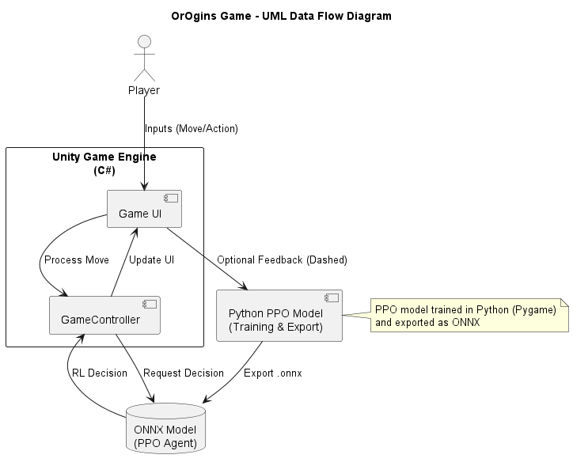

1. **Technology Stack**

|  |  |
| --- | --- |
| **Component** | **Technology** |
| Frontend | Unity (C#) |
| Backend | Unity (C#) |
| Model development | Python (Pygame,PPO) |
| Version Control | GitHub |
| Development Methodology | SDLC + CRISP-DM |

1. **Visual Design & UI**

* Minimalist UI for accessibility.
* Clear visual feedback for AI moves and user interactions.
* Icons/symbols to be considered instead of text for cross-platform compatibility

1. **Security & Data Protection**

* No external data collection from player
* AI operates on local simulation data only.

1. **Future Scalability Considerations**

* Support for multiplayer mode.
* Online game deployment